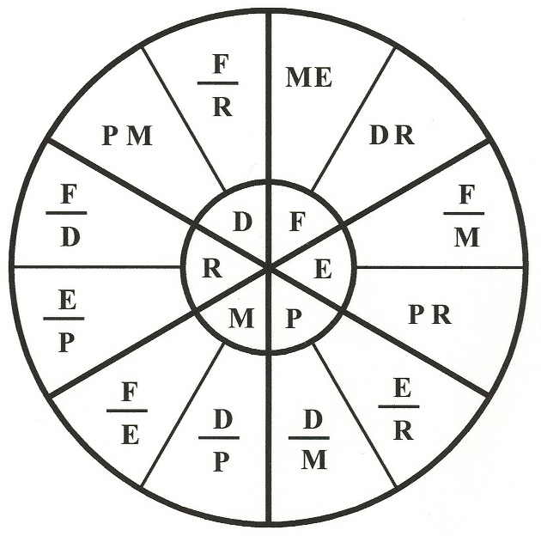

**TELESCOPE FORMULA WHEEL**

The unknowns are at the wheel's center .

The outer sections each provide two

equations that can be used to find the

associated unknowns.

For instance**, F = M * E**, and **P = D / M**.

**D** is the **Diameter** of the objective lens

**F** is the **Focal length** of the objective

**R** is the focal **Ratio** of the objective

**E** is the **Eyepiece** focal length

**M**  is the **Magnification** of the system

**P** is the exit **Pupil** diameter

**POLAR ALIGNMENT OF EQUATORIAL MOUNT BY STAR DRIFT:** Select two stars, each about 45* above the horizon: One in the east or west and one near the meridian. Roughly align mount toward north pole. Point the telescope at the stars as noted, observing which direction it drifts after each adjustment.

**ALIGN AZIMUTH FIRST:**

**IF MERIDIAN STAR DRIFTS NORTH THEN AZIMUTH TOO WEST**

**IF MERIDIAN STAR DRIFTS SOUTH THEN AZIMUTH TOO EAST**

**THEN ALIGN ALTITUDE:**

**IF EAST STAR DRIFTS SOUTH THEN ALTITUDE TOO LOW**

**IF EAST STAR DRIFTS NORTH THEN ALTITUDE TOO HIGH**

**IF WEST STAR DRIFTS NORTH THEN ALTITUDE TOO LOW**

**IF WEST STAR DRIFTS SOUTH THEN ALTITUDE TOO HIGH**

**High visibility version for low light conditions:**

**IF M * DRIFT N THEN AZ TOO W**

**IF M * DRIFT S THEN AZ TOO E**

**IF E * DRIFT S THEN ALT TOO L**

**IF E * DRIFT N THEN ALT TOO HI**

**IF W * DRIFT N THEN ALT TOO L**

**IF W * DRIFT S THEN ALT TOO HI**